Important Note

N.B. This is merely a reference to the problems, inclusive and exclusive of the questions that will be set in the exam. These exercise problems do not include all types of questions that may appear on the examination. The sole purpose of this is to facilitate a clear and thorough understanding of the concepts.

DDA
DDA
- Using the DDA algorithm, find out the first 10 pixels of the lines whose endpoints are given: (Always use the Revised DDA, even if not mentioned)
  - (20, 5), (15, 50)
  - (-5, 50), (-15,0)
  - (-10, -10), (48, 24)
  - (48, 24), (-10, -10)
  - (-1011, -2022), (-2022, -1011)

Note: The order of endpoints can affect the conditions selected from the DDA Algorithm (Check c and d). But the pixels will be the same.

MPL
Midpoint Line
- Using the Slope-Independent Line Drawing Algorithm (MPL with 8-way symmetry), find the first 10 pixel values starting from: (Show the present value of d at each stage in a table)
  - (20, 10) to (30, 18)
  - (0, -14) to (-45, 11)
  - (-1011, -29) to (-5509, 823)
  - (-18, 11) to (0, -3)
  - (0, -3) to (-18, 11)
  - (5, 10) to (-20, 5)
- Suppose a line segment has the equation 12x - 5y = 0, and the starting point is at y = 12 and the ending point is at y = 0. Find the first 6 pixels using the Midpoint Line Drawing Algorithm.
- A line with the equation, y = -5x - 20, starts from where it cuts the y-axis and ends at where it cuts the x-axis. Find the first 8 pixels using the Midpoint Line Drawing Algorithm.
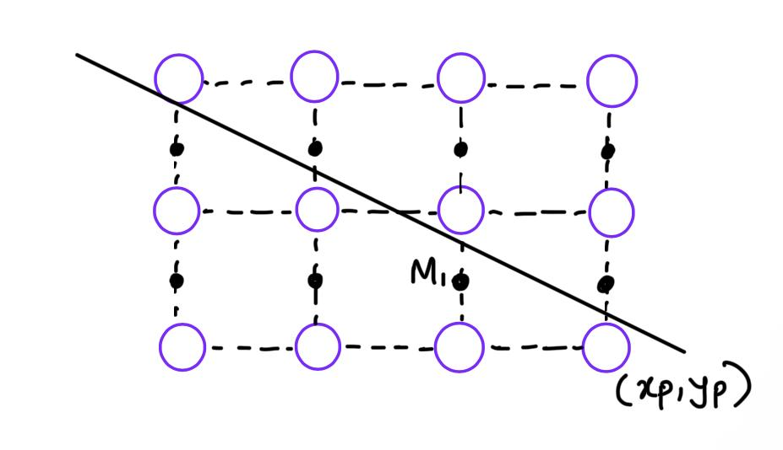
- A line segment has the above orientation. Derive starting/initial deviation (‘d’) and its derivatives (Δs)/decision parameters using the mid-point line drawing algorithm.
- —------

Line Clipping
Line Clipping Algorithms
- Given (0, 0) and (400, 300) are the corners of the clip rectangle. The endpoints of a line are given as (−50, 350) and (450, 330). Using the Cohen-Sutherland line clipping algorithm, identify whether the lines are Accepted, Rejected, or Partial (partially accepted) only from the outcodes. Does the Cyrus-Beck line clipping algorithm produce the same output?
- Given (-30, -30) and (30, 30) are the corners of the clip rectangle. The endpoints of a line are given as (-80, 35) and (35, -80). Using the Cohen-Sutherland line clipping algorithm, identify whether the lines are Accepted, Rejected, or Partial (partially accepted) only from the outcodes. Does the Cyrus-Beck line clipping algorithm produce the same output?
- The top-right corner of a clipping rectangle is (20, 60). The window is 60 units wide and 40 units tall. The endpoints of a line segment are (7, 16) and (85, 75). Apply the Cohen-Sutherland Algorithm and identify whether the line is "partially inside", "completely inside", or "completely outside". If it is the first case, run the algorithm to calculate new endpoints for the line segment so that it is inside the clipping window. Does the Cyrus-Beck line clipping algorithm produce the same output?
- A clipping window is 70 units wide and 30 units tall, and has its center at (0, 35). The endpoints of a line segment are (-45, 65) and (23, -10). Apply the Cohen-Sutherland Algorithm and identify whether the line is "partially inside", "completely inside", or "completely outside". If it is the first case, run the algorithm to calculate new endpoints for the line segment so that it is inside the clipping window. Does the Cyrus-Beck line clipping algorithm produce the same output?
- Given a line segment from (10, 60) to (25, 30). Construct the parametric equation P(t) of the line. Using the parametric equation, determine the coordinates of the point where t = 3/5.
- A three-dimensional clipping volume has two opposite corner points - A(–5, –4, 0) and B(5, 4, 10). A is the bottom-left corner of the farthest distance. Compute the outcodes of the 3D line segment from P(6, 6, 12) to Q(7, 7, 15)

Transformation
Transformation

- Derive a |4x4| rotation matrix for a 3D point while;
  - Rotation across the X-axis and the center of rotation (a, b, c).
  - Rotation across the Y-axis and the center of rotation (a, b, c).
  - Rotation across the Z-axis and the center of rotation (a, b, c).
*** If not mentioned, consider the rotation as anticlockwise direction
- Derive a |3x3| transformation matrix for reflection about any line L.
- Determine the coordinate of a 3D point P(100, -60, 80)
  - After rotating 60⁰ across the Y-axis, given that the center of rotation is (50, 20, 45).
  - After rotating 60⁰ across the X-axis, given that the center of rotation is (50, 20, 45).
  - After rotating 60⁰ across the Z-axis, given that the center of rotation is (50, 20, 45).
- Find the following composite and inverse composite transformation matrices as instructed:
  - A 3D rotation of 90⁰ clockwise about the y-axis with respect to the point (a, b, c), followed by a translation of (a, b, c).
  - A reflection about the line ax - by + c = 0 followed by a scaling “e” times with respect to the point (a, b).
  - A 3D rotation of 45° counterclockwise about the z-axis with respect to point (d, e, f), followed by a uniform scaling of factor 3 with respect to point (d, e, f), and lastly followed by a translation of (a, b, c). [Here, a, b, c, d, e, f are arbitrary values]
- Arya drew a triangle on a coordinate plane with vertices A(3, 2), B(5, 1), and C(4, 3). She performed the following transformations in sequence: At first, she translated the triangle by (−2, 3). Then, rotate the triangle 90⁰ counterclockwise about the origin. After that, she reflected the triangle on the x-axis. Finally, she scaled the triangle uniformly by a factor of 2 about the point (1, −1). After applying these transformations, the new location of one vertex was found to be (a, b).
  - Now, identify the position of the vertices before the reflection is applied. (That means only translation and rotation are applied to each of the vertices.)
  - Write the composite and inverse composite matrix formulation for all transformations applied to the triangle. (You do not need to perform matrix multiplication.)
  - Which geometric properties (angles, orientation, distances, parallelism, and collinearity) are preserved after each transformation?
- A 3D composite transformation is defined by a shearing along the X axis by a shearing factor of (2, 4) about point (423, 0, 0), followed by a uniform scaling by factor 3 again, followed by a 30-degree counterclockwise rotation on the X axis about point (2, 10, 12) and finally followed by a translation of (-4, -2, -3). A point P is transformed into P’ with the above transformation.
  - Now, write down the composite transformation matrix representation for P’ in the correct sequence of matrix multiplications. [N.B. The shearing factor will be Sh_{y = 2} and Sh_{z = 4}. Go sequentially if it is not mentioned.
  - Also, find out the inverse composite transformation matrix representation for P’ in the correct sequence of matrix multiplications.
- A 3D point M is transformed to M’ by applying shearing along the Y Axis by a shearing factor of (12, 21) with respect to a point (-33, 44, -55). If the old coordinate, M, is (125, 255, -674). What was the new coordinate, M’?
- A composite transformation is defined by a shearing about the Y-axis (first transformation) followed by a second transformation, via the following equations:
$x′ = x + 77y +423$
$y′ = y +421$
$z′ = 370 + 99y + z$
- Find the composite transformation matrix. What was the second transformation after shearing?
- Write down the shearing matrix from the above composite transformation.
- If a point P′(4, 2, 3) is the transformed coordinates of point P after a composite transformation that is defined by a rotation of 90° clockwise about the Y-axis, followed by the previously mentioned second transformation, determine the coordinates of point P before transformation.
- A composite transformation is defined by a scaling on the X-axis and Y-axis (first transformation) followed by a second transformation, via the following equations:
x′ = 5x - 11
y′ = 10y + 22
z′ = 33 + z
- Find the composite transformation matrix. What was the second transformation after scaling?
- Write down the scaling matrix from the above composite transformation.
- If a 3D point M has the coordinate (4, 2, 3), what is the new coordinate of the point M’ after the transformation defined by the equations?
- A robot is positioned at (2, 0, 3) with the endpoint of its hand at (2, -2, 1). The robot wants to grab a fruit located at (12, 5, 13). To achieve this, it performs the following transformations sequentially on its hand's endpoint:
- Rotation: At first, the hand’s endpoint is rotated 90° counter-clockwise around the X-axis, using the robot’s position as the center of rotation.
- Scaling: Then, the hand's endpoint is scaled by some factors of S_{x}, S_{y}, and S_{z}. [Hint: Scaling was done with respect to the Robot’s position, too.]
- Translation: Lastly, the robot itself is translated by (10, 0, 15), bringing the hand’s endpoint to the fruit’s position so that it can grab the fruit.
Find the values of S that ensure the hand’s endpoint aligns with the fruit (the hand’s endpoint will be the same as the fruit’s location to grab the fruit). Show your calculations using the composition of transformations. Also, explain whether the scaling is uniform or non-uniform.

